**Mesh material tool documentation**

This tool is designed to find all the materials attached to a 3d mesh and either apply new materials or and keep any existing ones that don’t have any new materials for them.

**Open the window**

This tool can be opened in three ways:

1. If you are using the J-Tools window you can open and close the window from that window’s buttons.
2. You can open the window by going to the following path: ***Window -> Mesh Material Tool.***
3. If you are on windows you can use the shortcut **Shift-M** to open the window.

**Summary**

To apply new materials

Select all the meshes you wish to change the materials on.

**Note:** *All the meshes have to be the same model for this to work reliably, having different meshes may cause issues when applying and is not recommended.*

Then click the Find button, doing this will populate the 2 arrays on the editor window. The first array will fill up with the materials on the meshes, while the second array will fill up with null materials for each material found.

Next fill the second array with any materials you wish to modify. To do this match the element in the array with the element you wish to change, the find the material you wish to apply and select it. Once you are done with selecting materials to change, leaving the rest of the slots you wish to remain the same blank, press the Apply button. If you’ve done it right the new materials should now be added to the meshes you had selected.

To Undo your last change

If you made a mistake with your last material change, you can go back by simply pressing the Undo Last button.

**Note:** *This button only undoes the last change at the moment, a future iteration of the tool may be able to store all your changes and you’ll be able to undo and redo. For the time being though, please take care when changing to make sure you don’t make mistakes as Ctrl-Z does nothing when using this tool.*

To clear the array without applying

To clear the arrays, you can simply press the Clear button.

**Note:** This will clear both the array’s, you will need to press Find again to repopulate the arrays and use the tool. The arrays will auto reset after each press of the Apply button as well, so this button is to be used to clear any mistakes made before applying.

**Tool Screenshot**

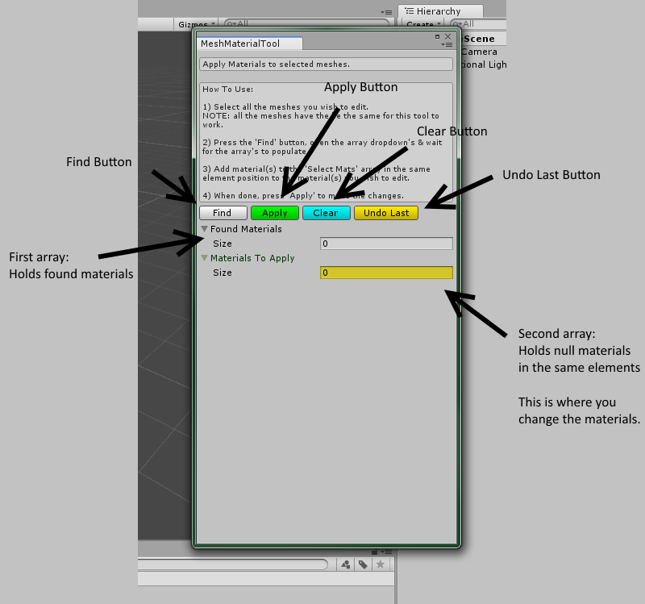If you are stuck on what is what on the tool, here is an annotated screenshot that should help: